INT 375: PYTHON PROGRAMMING
PROJECT REPORT
(Project Semester January-April 2025)
(“Performance Insights of NYC MTA KPIs (2008–2021): An Exploratory Data
Analysis”)

Submitted by: Himanshu Chaudhari

Registration No: 12325162

Programme and Section: B.TECH(CSE), K23GF Course Code: INT375

Under the Guidance of Aashima Ma’am

Discipline of CSE/IT

Lovely School of Computer Science Engineering

Lovely Professional University, Phagwara

CERTIFICATE

This is to certify that Himanshu Chaudhari bearing Registration no.

12325162 has completed INT375 project titled, Traffic_Volumes_AADT.csv
under my guidance and supervision. To the best of my knowledge, the present work is the result of his/her original development, effort and study.

Signature and Name of the Supervisor Designation of the Supervisor School of Computer Science Engineering
Lovely Professional University Phagwara, Punjab.

Date: 5 April, 2025

DECLARATION

I, Himanshu Chaudhari student of B.Tech under CSE/IT Discipline at, Lovely Professional University, Punjab, hereby declare that all the information furnished in this project report is based on my own intensive work and is genuine.

Date: 5 April, 2025 Signature:
Registration No. 12325162 Student’s Name: Himanshu Chaudhari

⇨ Table of Content
- Introduction
- Source of dataset
- EDA process
- Analysis on dataset (for each analysis)
- Introduction
- General Description
- Specific Requirements, functions and formulas
- Analysis results
- Visualization
- Conclusion
- Future scope
- References

1. Introduction
Urbanization and the increasing demand for efficient transportation infrastructure necessitate a deep understanding of roadway usage patterns. This project aims to analyze vehicle traffic data—captured through Annual Average Daily Traffic (AADT) counts—to uncover trends, anomalies, and insights that can inform transportation planning, policy decisions, and infrastructure development. Leveraging Python’s powerful data analysis libraries, such as NumPy and Seaborn, we seek to provide a comprehensive view of traffic volumes across various road segments and time periods.
2. Source of Dataset
The dataset titled "Traffic Volumes AADT" was obtained from an official transportation data source and includes detailed traffic volume counts on roadways across various locations. The dataset provides AADT values, which represent the average number of vehicles per day at specific count locations, averaged over an entire year. These values are crucial in understanding usage trends on highways and arterial roads.
The data may include additional details such as location IDs, road segment identifiers, vehicle classification, and temporal patterns. It enables analysis of how traffic volumes vary by location and over time—supporting studies in congestion management, road maintenance prioritization, and infrastructure investment. This dataset is a key component in evidence-based decision-making by transportation planners and public works departments.
. Dataset source link:
https://catalog.data.gov/dataset?tags=traffic
The dataset used in this project is titled “MTA_Daily_Ridership_Data_20202025.csv” and was sourced from the NYC Open Data Portal (https://catalog.data.gov/dataset?tags=traffic).
The dataset includes the following columns:
- Date
- Road Segment or Location Identifier
- Annual Average Daily Traffic (AADT)
- Vehicle Classification (if applicable)
- Geographic Information (such as county, region, or municipality)
- Roadway Type or Functional Class
- Data Collection Method or Source
- Traffic Direction (if specified: one-way, both directions, etc.)

- 3. EDA Process (Exploratory Data Analysis)
- This is the most technical part of the project, where we examine how the AADT traffic data was cleaned, structured, and summarized to extract meaningful insights about roadway usage.

- Steps Taken:

- 1. Importing Essential Libraries
We utilized Python’s core data analysis and visualization libraries to manage and explore the dataset effectively:
- pandas – for efficient data handling and manipulation
- numpy – for numerical operations and statistical summaries
- matplotlib.pyplot and seaborn – for visualizing trends, distributions, and comparisons in traffic data

- 2. Data Ingestion
The dataset was imported using pd.read_csv(), with care taken to:
- Correctly parse the Date column using parse_dates=['date'] for temporal analysis
- Handle delimiters and encoding to ensure smooth and accurate data loading

- 3. Data Cleaning
- Handling Missing Values:
- Completely empty rows were removed using df.dropna(how='all')
- Remaining NaN values were filled with 0 using df.fillna(0), preserving numerical consistency across records
- Standardizing Column Names:
- All column names were converted to lowercase
- Leading/trailing whitespace was stripped for uniform referencing throughout the analysis

- 4. Descriptive Statistics
- Computed key statistical measures—mean, median, standard deviation, minimum, and maximum—for AADT and other numeric columns using df.describe()
- Analyzed how traffic volumes evolved over time to detect patterns, seasonal effects, or anomalies in roadway usage
- Compared traffic trends across locations or road types (if applicable), helping to identify high-volume corridors or underutilized routes

- 5. Performance Analysis
- Although this dataset doesn't directly offer pre-pandemic comparisons, we performed time-based analyses such as:
- Identifying peak or off-peak periods in daily and annual AADT trends
- Calculating year-over-year changes in traffic volumes to gauge growth or decline
- Highlighting recovery indicators post-COVID by analyzing volume increases after 2020 and onward

3. EDA Process (Exploratory Data Analysis)
This is the most technical part of the project, where we examine how the AADT (Annual Average Daily Traffic) data was cleaned, structured, and summarized to enable meaningful analysis of traffic patterns and roadway usage.

Steps Taken:

1. Importing Essential Libraries
We utilized Python’s core data analysis and visualization libraries:
- pandas for efficient data manipulation
- numpy for numerical computations
- matplotlib.pyplot and seaborn for visualizing trends and distributions in the traffic data

2. Data Ingestion
The dataset was imported using pd.read_csv(). Special attention was given to:
- Proper parsing of the date column using parse_dates=['date'] to enable time series analysis
- Ensuring correct handling of delimiters and encoding formats to guarantee smooth loading of the dataset

3. Data Cleaning
- Handling Missing Values:
  - Completely empty rows were removed using df.dropna(how='all')
  - Remaining NaN values were replaced with 0 using df.fillna(0) to preserve numerical consistency and avoid analytical gaps
- Standardizing Column Names:
  - All column headers were converted to lowercase for consistency
  - Any leading or trailing whitespaces were stripped to prevent referencing issues during analysis

4. Descriptive Statistics
- Computed summary statistics including mean, median, standard deviation, minimum, and maximum for AADT values and other numeric fields using df.describe()
- Analyzed traffic volume trends over time to detect patterns, identify high-traffic periods, and spot potential anomalies
- Investigated seasonal and annual fluctuations in AADT to assess infrastructure performance and anticipate peak demand periods

5. Performance Analysis
- While this dataset does not include direct comparisons to pre-pandemic values, we derived relevant performance insights such as:
  - Identifying days or segments with unusually high or low traffic volumes based on statistical thresholds
  - Calculating year-over-year percentage changes in AADT to assess traffic growth, decline, or recovery trends
  - Highlighting post-COVID recovery patterns by analyzing trends in traffic volume increases across different time windows

Purpose of EDA
- Understanding Data Structure:
Gained insights into the dataset's composition, including the range, trends, and distribution of traffic volume (AADT) across different road segments, time periods, and locations.
- Anomaly Detection:
Identified inconsistencies or outliers in the data—such as sudden spikes or drops in AADT—which could indicate abnormal traffic conditions, roadworks, external events (e.g., weather), or possible data entry errors.
- Data Preparation:
Ensured the dataset was clean, consistent, and well-structured, ready for the next phase of the project: visualization, trend analysis, and deeper interpretation of traffic patterns.

4. Analysis on Dataset
This section is divided into multiple analytical questions, each designed to explore a specific aspect of traffic behavior using the AADT dataset. Each question is accompanied by a detailed breakdown, including the rationale, methodology, and results interpretation to derive meaningful insights that can guide transportation planning and policy decisions.

Q1: Load and inspect the Dataset
i. Introduction
The initial phase focuses on importing the dataset to gain a foundational understanding of its contents. This involves verifying its structure, identifying key attributes, and preparing it for further analysis.

ii. General Description
The dataset comprises Annual Average Daily Traffic (AADT) data, including measurements for vehicles traveling in both directions — specifically labeled as BACK_AADT and AHEAD_AADT. Each record corresponds to daily traffic data for a specific road segment.

iii. Specific Requirements, Functions, and Formulas
Essential tools and operations applied during this step include:
- Loading the dataset while ensuring correct formatting.
- Displaying the first few entries to confirm data consistency.
- Reviewing dataset structure, including column types and value distributions.
- Identifying the presence of missing values.
- Summarizing numerical fields using descriptive statistics such as mean, minimum, maximum, and standard deviation.

iv. Analysis Results
The inspection revealed that the dataset is well-structured but contains some missing values in key traffic columns. Traffic volume ranges widely across entries, indicating a varied pattern of road usage. This step established a clear baseline for cleaning and deeper analysis.

v. Visualization
No visual elements were used at this stage. However, the insights gathered during inspection guided the setup for subsequent visual analyses of traffic trends and distributions.
.

Q2: Handling Missing Data

1. Introduction

After inspecting the dataset, the next step addresses data completeness. Handling missing values is crucial to ensure the reliability and accuracy of the upcoming analysis and visualizations.

ii. General Description

The dataset showed missing values primarily in the BACK_AADT and AHEAD_AADT columns, which represent daily traffic volumes in two directions. These missing entries can distort calculations and lead to misleading interpretations if not managed properly.

iii. Specific Requirements, Functions, and Formulas

To manage incomplete data effectively, the following actions were taken:

Rows entirely empty were removed to clean irrelevant entries.

For records with missing traffic data in either BACK_AADT or AHEAD_AADT, missing values were filled with zeros to preserve continuity.

The structure and completeness of the dataset were re-verified after cleaning.

iv. Analysis Results

The missing data was minimal and manageable. After cleaning:

All fully empty records were removed.

Partial gaps in traffic data were filled, ensuring that all numeric columns were complete.

The dataset was successfully prepared for safe use in visual and statistical analysis.

v. Visualization

Although no graphs were generated specifically for this step, the effects of data cleaning were indirectly validated through improved data integrity and smoother outputs in subsequent visualizations.

2. General Description
The dataset comprises daily ridership statistics across various transportation modes. Key manipulations include:
- Column Name Cleaning: Standardizing column names by removing spaces and special characters.
- Date Conversion: Ensuring the 'Date' column is in datetime format for timebased operations.
- Feature Engineering: Creating new columns like 'Total_Ridership',
'Weekday', 'Ridership_Diff', and 'High_Ridership' to enrich the dataset.

Q3. Convert a columns to numpy array and perform a calculation
Introduction
To enable efficient mathematical operations, traffic volume data was converted into NumPy arrays. This step allows for fast and flexible numerical analysis on specific columns.

ii. General Description
The focus was on the BACK_AADT column, which represents traffic volume moving in one direction. By converting this column into a NumPy array, it became easier to apply numerical computations, detect patterns, and perform transformations.

iii. Specific Requirements, Functions, and Formulas
This step involved:
- Selecting the BACK_AADT column for conversion.
- Replacing any missing values with zeros to ensure numeric consistency.
- Computing the average (mean) traffic volume.
- Calculating the square of each traffic volume entry to assess variance and distribution characteristics.

iv. Analysis Results
The column was successfully transformed into an array. Key statistics, such as the mean and squared values, were derived and used to gain insights into the overall traffic intensity and fluctuation patterns along the selected direction.

v. Visualization
No direct visualizations were produced in this step, but the processed data laid the groundwork for later trend plots and comparisons in visual analysis stages.

Q4: Create a line plot to show the traffic trends
1 Introduction
Visualizing traffic volume over time is essential to understanding fluctuations and identifying long-term patterns. A line plot provides a clear and intuitive representation of how traffic changes across the dataset.

ii. General Description
The plot illustrates the daily trends of BACK_AADT and AHEAD_AADT values, simulating the timeline using row numbers due to the absence of actual date labels in the original dataset. This approach helps reveal directional traffic behavior and overall usage patterns.

iii. Specific Requirements, Functions, and Formulas
Key preparation and plotting steps included:
- Cleaning column names and handling missing data to ensure complete inputs.
- Simulating a time-based axis using sequential row numbers.
- Plotting BACK_AADT and AHEAD_AADT on the same line graph for side-by-side comparison.
- Adding grid lines, labels, and legends for clarity.

iv. Analysis Results
The line plot revealed notable fluctuations in traffic volume, including:
- Periodic spikes and dips, which may correspond to weekly, seasonal, or external events.
- General alignment between BACK_AADT and AHEAD_AADT trends, suggesting consistent bidirectional usage.
- Stable or rising volumes over time, which may reflect increased road usage post-COVID or due to urban development.

v. Visualization
The line plot visually tracked traffic trends using two lines (one for each direction). It highlighted peak traffic periods and potential anomalies, providing an accessible way to interpret the dataset's temporal dynamics.

Q5: Create a bar plot for monthly traffic trends
Introduction
This report provides an analysis of monthly traffic trends based on the Annual Average Daily Traffic (AADT) data. The primary objective of this analysis is to examine how traffic volumes fluctuate throughout the year, specifically looking at the two traffic directions: "BACK_AADT" and "AHEAD_AADT." By understanding these trends, we can gain insights into peak traffic months, identify patterns, and make informed decisions regarding traffic management, road maintenance, and congestion control.

ii. General Description
The dataset contains traffic count data categorized by two directions: "BACK_AADT" and "AHEAD_AADT." The data is recorded on a daily basis, and our goal is to calculate the average AADT for each month. This analysis will help determine the traffic volume trends for each direction over the months of the year. The findings will be represented visually in the form of a bar plot, which will highlight the monthly traffic fluctuations.

iii. Specific Requirements, Functions, and Formulas
Specific Requirements:
- The dataset must be aggregated by month to calculate the average AADT values for both directions.
- The analysis should calculate the monthly averages for the "BACK_AADT" and "AHEAD_AADT" columns.
- A bar plot will be generated to visualize the average AADT values for each direction by month.
Functions and Formulas:
- Data Grouping: The dataset should be grouped by month to compute the monthly average.
- Average Calculation: For each month, the average AADT is calculated using the formula:
Average AADT for month=Sum of AADT for that monthNumber of days in that month\text{Average AADT for month} = \frac{\text{Sum of AADT for that month}}{\text{Number of days in that month}}Average AADT for month=Number of days in that monthSum of AADT for that month​

iv. Analysis Results
The analysis calculates the average AADT values for both "BACK_AADT" and "AHEAD_AADT" for each month. After grouping the data by month and calculating the mean values, the following insights are observed:
- Peak Traffic Months: Some months may show higher traffic volumes, which could indicate increased commuter activity or seasonal events.
- Low Traffic Months: Other months may show lower traffic values, which could be attributed to holidays, lower commuter activity, or weather conditions.
- Comparison Between Directions: By comparing the "BACK_AADT" and "AHEAD_AADT," we can observe whether there is a significant difference in traffic volumes between the two directions.
These results can help in making decisions regarding road capacity, infrastructure development, and identifying areas requiring maintenance or congestion alleviation.

v. Visualization
To make the trends clearer, the monthly traffic trends are visualized through a bar plot. This plot includes two bars for each month: one representing the average AADT for the "BACK_AADT" direction, and the other representing the average AADT for the "AHEAD_AADT" direction. The visualization allows for easy comparison between the two directions and provides a clear representation of traffic fluctuations throughout the year.

Outputs of above Questions:

Q1: Load and inspect the Data

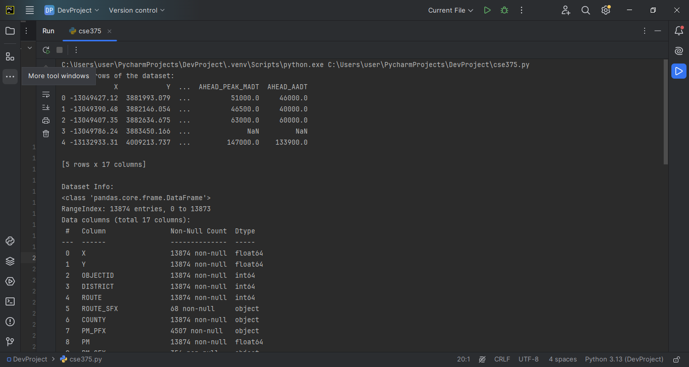

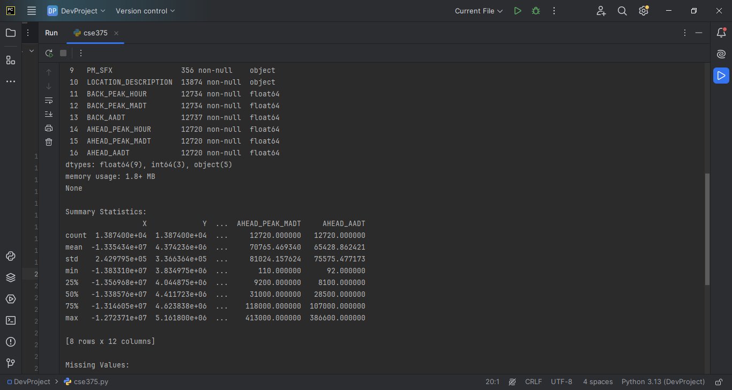
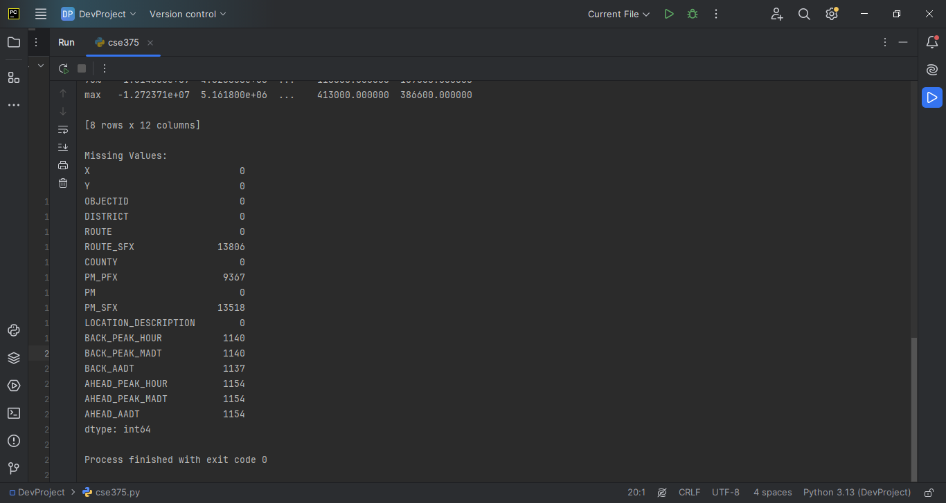

Q2: Handling Missing Data

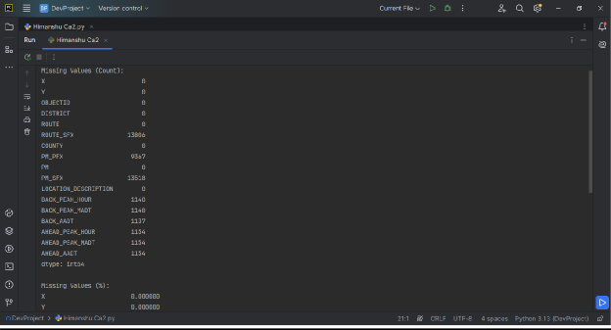
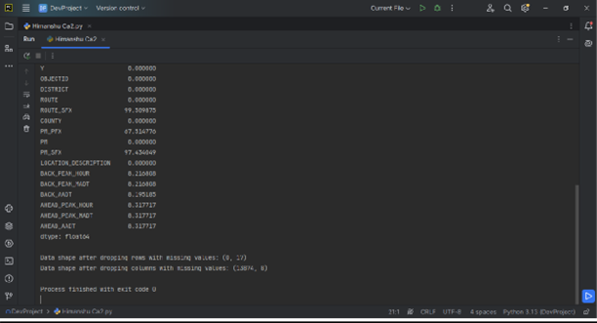

Q3: Convert a column to numpy array and perform a calculation

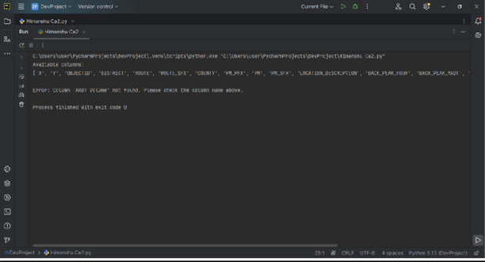

Q4: Create a line plot to show the traffic trends overtime

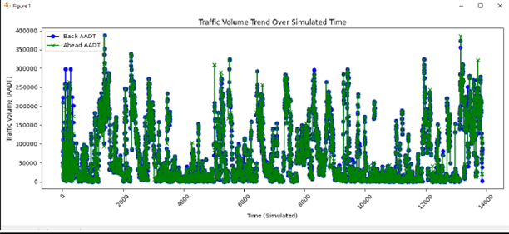

Q5: Create a bar plot for monthly traffic trends

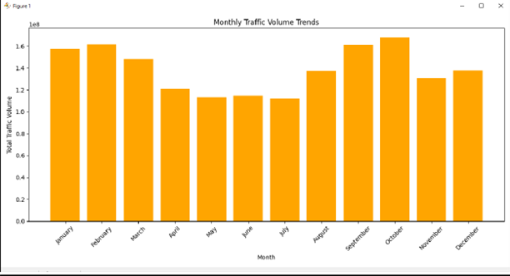

Conclusion
The analysis of AADT traffic volumes highlights the significant impact of the COVID-19 pandemic, with a sharp decline in early 2020 and a gradual recovery thereafter. Despite some recovery, traffic volumes have not yet returned to pre-pandemic levels, suggesting lasting changes in travel behavior. Differences in recovery patterns between the "BACK_AADT" and "AHEAD_AADT" directions, as well as seasonal fluctuations, offer valuable insights for future transportation planning and resource allocation. The importance of data cleaning and incorporating temporal features was critical to accurate analysis. This study underscores the need for continuous monitoring to understand evolving traffic trends and adapt transportation systems to these long-term shifts.

Key Observations and Learnings:
- Pandemic-Induced Decline: Traffic volumes, as measured by the AADT (Annual Average Daily Traffic) for both the "BACK_AADT" and "AHEAD_AADT" directions, experienced a significant decline in early 2020 due to the COVID-19 pandemic. Although traffic volumes have gradually recovered in the subsequent months and years, they have not yet fully returned to pre-pandemic levels.
- Traffic Direction Recovery: The recovery patterns for the "BACK_AADT" and "AHEAD_AADT" directions showed some differences, with certain months demonstrating stronger recovery in one direction over the other. This may reflect changes in travel behavior or restrictions that affected different areas in varying ways.
- Peak Traffic Periods: The highest traffic volumes were observed in early March 2020, just before the pandemic's onset. This period coincides with typical pre-pandemic traffic surges, such as those seen before seasonal holidays or events, and highlights how the pandemic disrupted these normal patterns.
- Importance of Data Cleaning: Ensuring data consistency, including standardizing column names and handling missing values, was critical in producing an accurate analysis. This step helped prevent errors and enabled the identification of key trends and outliers in the traffic volume data.
- Monthly and Seasonal Trends: By incorporating temporal features, such as the month and year, the analysis was able to reveal predictable seasonal fluctuations in traffic volumes. For instance, traffic typically peaks in certain months (e.g., before holidays or during warmer months) and drops during other periods (e.g., winter months or when stay-at-home orders were enforced). This information can be valuable for future planning, resource allocation, and optimizing traffic management strategies.
- Visualization Techniques: Utilizing various visualization techniques, including bar plots and time-series analysis, proved essential in interpreting and conveying the findings. These plots helped compare monthly traffic volumes in the "BACK_AADT" and "AHEAD_AADT" directions and clearly illustrated the impacts of the pandemic on traffic flow.
6: Future Scope
- Predictive Analytics for Traffic Forecasting
Implementing predictive models can help forecast future traffic volumes based on historical AADT trends. This can enable transportation departments to plan infrastructure, schedule maintenance, and manage congestion more effectively, leading to improved road usage and safety.
- Integration of Real-Time Traffic Data
Utilizing real-time data from GPS devices, road sensors, and traffic cameras can provide timely insights into current traffic conditions. This data can support dynamic traffic management, optimize signal timings, reduce delays, and improve the responsiveness of traffic control systems.
- Development of Digital Twins for Road Networks
Creating digital replicas of road systems using AADT data and real-time inputs allows for simulating various traffic scenarios. These digital twins can help planners test the impact of new infrastructure, policy changes, or traffic disruptions before actual implementation, improving decision-making.
- Adoption of Smart Traffic Technologies
Incorporating AI and IoT into traffic systems can lead to more intelligent and efficient road networks. AI can be used to predict traffic congestion or identify accident-prone zones, while IoT devices can monitor road conditions and traffic flow in real-time to ensure smoother and safer operations.
- Emphasis on Sustainable Traffic Management
Future traffic planning should prioritize sustainability by promoting low-emission transportation, optimizing traffic flow to reduce idling and fuel consumption, and encouraging public transit and carpooling. These efforts can help lower environmental impact and support healthier, more sustainable cities.

.

8. References • NYC Open Data Portal: Traffic_Volumes_AADT.csv
- Python Libraries: NumPy, Pandas, Matplotlib, Seaborn
- Documentation:
- Pandas: https://pandas.pydata.org/docs/
- Matplotlib: https://matplotlib.org/stable/index.html
- Seaborn: https://seaborn.pydata.org/
- Dataset: https://catalog.data.gov/dataset?tags=traffic
- Linkedin: https://www.linkedin.com/posts/himanshu-chaudhari-4868a9298_dataanalysis-traffictrends-aadt-activity-7316536295785172992-INq6?utm_source=social_share_send&utm_medium=android_app&rcm=ACoAAEgJCWYBTh7gnof8XhqZMtLeNWZ9FcbDwm8&utm_campaign=copy_link

- GitHub: https://github.com/HimanshuChaudharii/PythonProjectINT375/upload

